**Objectives:**

* Solve trigonometry questions, relating to **right triangles**, using these ratios:

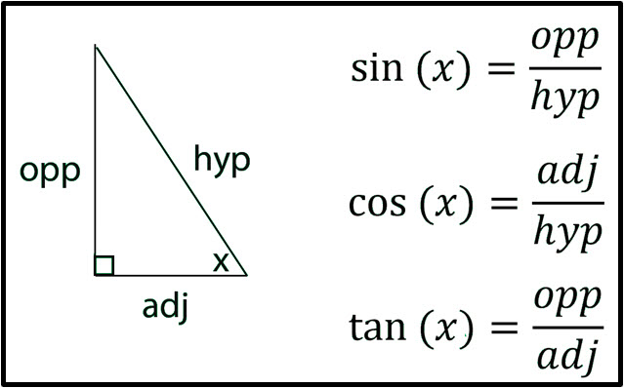

* Use the inverse sine (arcsin), inverse cosine (arccos), and inverse tangent(arctan) to find the measure of an angle in a triangle.
* Know that an **oblique** triangle is a triangle that does **not** contain a right angle.
* Use the **Law of Sines** to solve a right triangle **or** an oblique triangle when given AAS, ASA, or SSA (Ambiguous Case).

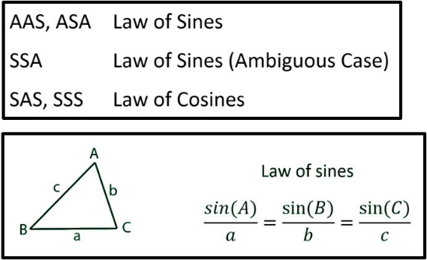

* Use the **Law of Cosines** to solve a right triangle **or** an oblique triangle when given SAS or SSS.

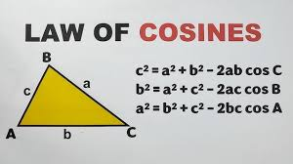

* Be able to find the areas of both right and oblique triangles.
* Use Area = 0.5(base)(height) for right triangles and oblique triangles when you know the base and the height.
* Use The Law of Sines Area Formula for oblique triangles when you know 2 sides and an included angle (SAS).
* Use Hero’s (Heron’s) Formula when you know all 3 sides (SSS).
* Know that π radians = 180o. Be able to convert radians to degrees and degrees to radians.

**Monday (3.31.25)**

Do you have any remaining questions about the previously assigned Trig Review?

**Class Work/Homework:**

* Study for your **Trig Test to be taken on Wednesday, April 2.** You may use your notes when you take this test.
* Class Work (to be turned in today): ***The Law of Cosines Practice*** (Handout).
* ***Take-Home Quiz, A Triangle Puzzle:*** Due Wednesday, 4.2.25.

**WEDNESDAY (4.2.25)**

**Trig Test.** You may use your notes.

**Turn in your *Take-Home Quiz, A Triangle Puzzle.***

**Friday, 4.4.25 ACT/SAT Testing for all juniors**

**New Objectives:**

* Find the midpoint between 2 points.
* Find the distance between 2 points.
* Identify an arithmetic sequence.
* Give the common difference of an arithmetic sequence.
* Find the nth term of an arithmetic sequence.
* Find arithmetic means between 2 terms of an arithmetic sequence.
* Find the sum of an infinite arithmetic sequence.
* Identify a geometric sequence.
* Give the common ratio of a geometric sequence.
* Find the nth term of a geometric sequence.
* Find geometric means between 2 terms of a geometric sequence.
* Find the sum of an infinite geometric sequence.

**Class Work:**

1. Find the midpoint between the points (-8, 3) and (27, 10).
2. Find the distance between the points (-8, 3) and (27, 10). Round your answer to one decimal place.

**Class Work/Homework:**

**View and take notes on the following 2 videos:**

* ***Arithmetic Sequence - Write Equation (Formula):*** [**https://youtu.be/MrVvS4ym8zQ?si=7J9ou6_o5PRH22k9**](https://youtu.be/MrVvS4ym8zQ?si=7J9ou6_o5PRH22k9)
* ***Sum of an Arithmetic Series Formula*:**

[**https://youtu.be/TtJ4dphwh0U?si=Y2RSliiG8lLRkc0g**](https://youtu.be/TtJ4dphwh0U?si=Y2RSliiG8lLRkc0g)

**Saturday, 4.5.25 E-LEARNING DAY**

**View and take notes on the following 2 videos:**

* ***Geometric Sequence Formula:***

[**https://youtu.be/3xbormMmuK4?si=2tw2ytT7x5hi4toK**](https://youtu.be/3xbormMmuK4?si=2tw2ytT7x5hi4toK)

* ***Sum of a Geometric Series:***

[**https://youtu.be/x0h92Y576xY?si=L-7Z4Hp_bsl-d__0**](https://youtu.be/x0h92Y576xY?si=L-7Z4Hp_bsl-d__0)